Dot Watch Manual
DW01

[Table of Contents]
1. Before using your Dot Watch………………………………………2p
- Basic Components, Name and Function of Each Part, Dot Watch User Tutorial
2. Wearing the Dot Watch………………………………………5p
3. Using the Dot Watch………………………………………6p
- Downloading the Dot Watch App, User Guide, Turn On/Off, Charging the Battery, Checking the Battery Status, Pairing via Bluetooth, Unpairing Bluetooth Connection, Connecting to a New Phone, Checking the User Guide, Sleep Mode, Reverse Screen Mode
4. Dot Watch App………………………………………10p
- Register, Log-in, Resetting Password
- Dot Watch App Functions – Hi! User, Dot Watch, Functions, Settings, Help
5. Dot Watch Functions – Braille Mode, Tactile Mode
5-1) Common Functions………………………………………12p
- Learning Braille, Receiving Phone Calls, Finding My Smartphone, Remaining Battery Indicator, Battery Warnings, Reading Notifications, Methods of Reading Notifications, Saving Notifications onto the Dot Watch App, Checking Previous Notification Messages, Alarm Function, Resetting the Dot Watch
5-2) Braille Mode………………………………………15p
- Time, Date, Setting the Time Manually, Setting the Date Manually, Stopwatch, Timer, Bluetooth Connection Status Menu
5-3) Tactile Mode………………………………………17p
- Switching to Tactile Mode, Time and Date, Setting the Time Manually, Stopwatch, Timer, Bluetooth Connection Status Menu
6. Precautions………………………………………20p
6-1) Safety Precautions
6-2) Handling Precautions
7. Dot Watch Specifications………………………………………24p
8. Regulatory Notices………………………………………25p

Be sure to read this manual thoroughly before using your Dot Watch!
As the Dot cells are entirely of a different nature, it does require a certain level of a learning curve to grow comfortable with using the Dot Watch.
- The user input (e.g. pressing the buttons) and the actual user reading should be offset by about one second.
- Please note that, there can't be any pressure and/or blocked cells by fingers and/or foreign objects by the time the pins are trying to display, following input command.
- The user is responsible for understanding the above information, as incorrect displaying due to user error does not equate to a defective device.
- If your device unpairs from your smartphone due to any reasons (proximity, obstacles, powering off/on, etc.), refer to the steps in “Bluetooth Connection Status Menu” section to resume connection trials.
- To pair the Dot Watch with a new smartphone, the Bluetooth information stored in both the previous smartphone and the Dot Watch needs to be reset. Refer to the steps in “Connecting the Dot Watch to a New Smartphone” section to pair with the new smartphone.
This User's Guide is based on the default settings of the device. The contents of this manual may differ from the actual experience depending on the software version of the device, telecommunication service, model specifications, and the user's settings. The device is not supported on Tablet PCs such as iPad or Galaxy Tab.

1. Before Using Your Dot Watch
Dot Watch is a smart watch that connects to the user's smartphone via Dot Watch App and outputs all information in braille. Although Dot Watch can be operated as a standalone analog watch, the Dot Watch App and BLE (Bluetooth Low Energy) connection is recommended. iOS 9 or its later versions and Android 4.4.4 or a later version is required to run the Dot Watch App.

[Basic Components]
- Dot Watch
- Magnetic Charging Cradle (charger)
- Quick User Guide
- Warranty Card
* If you have any missing basic components, please contact the store where your purchase was made.
* Visit the official Dot Website (www.dotincorp.com) for purchasing optional devices that are not supplied as basic components.
[Name and Function of Parts]
The body of Dot Watch is round in shape. The front of the body is called “Dot Watch Screen”. There are total 4 dot cells on the screen; a vertical line at center divides the 2 cells on the left, and the other 2 on the right. Each cell represents one character; therefore, up to 4 characters can be displayed at a time. Below the cells are left and right “Touch Sensors”. The “Dot Crown” is located on the right of the center of the body. The "Select Button" is located above Dot Crown, and the "Home Button" is located below Dot Crown.
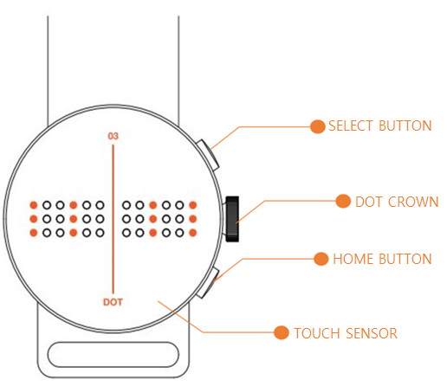
Figure 1. above highlights both of the buttons, Dot Crown and the Touch Sensor locations.

- Select Button: Press once to enter or operate each function.
- Home Button: Press once to go to “Standby” status. Press and hold the button for 3 seconds to turn the power on or off.
- Dot Crown: Turn upwards or downwards to navigate between functions.
- Touch Sensor: Press the Touch Sensor under the cells to scroll back and forth (left and right) through the braille while reading notifications.
[Dot Watch User Tutorial – Basic]
The Dot Watch Tutorial is available to assist the first time users to locate the braille cells, and to make it easy to understand how the "Select / Home Buttons", the "Dot Crown" and the "Touch Sensors" work.
Once the Dot Watch is paired with your smartphone, the tutorial begins, starting with “Checking the Braille Cells of the Dot Watch”.

1) Checking the Display
Check the position and the height of the braille cells. Press the “Raise the Pins” and “Drop the Pins” buttons on your Dot Watch App to raise and lower the braille cells on the Dot Watch Screen. When you have finished checking the braille cells, press “Next” to learn how to use the buttons.
2) Using the Buttons
Go through the guide carefully to learn the functions of the “Select Button”, and the “Home Button”. Each time you press the “Select Button”, you will notice the display changes from the current time (hour and minutes) to the seconds, and to the current date. Press “Next” to move to learn how to use the “Dot Crown”.
3) Using the Dot Crown
Each time you turn the “Dot Crown” up or downwards, you will notice the braille display changes with vibration to notify. Press “Next” to learn how to use the “Touch Sensors”.
4) Using the Touch Sensors
Try reading the numbers displayed on the screen, while navigating between the numbers using the “Touch Sensors”. Press the right “Touch Sensor” to see the next contents of the message, and the left “Touch Sensor” to see the previous contents. Press “Next” to start using the Dot Watch.
NOTE
- Pressing the left “Touch Sensor” at the beginning of the message, or pressing the right “Touch Sensor” at the end of the message will produce vibration to notify that it is either the beginning or the end of the message.
- The “Touch Sensors” are programmed not to work while the pins are still in the movement; therefore, pressing the “Touch Sensors” repetitively while the pins are still moving may cause the sensors not to fully respond. In this case, give it about one second, and scroll with the “Touch Sensors” again.

[Dot Watch User Tutorial – Advanced]
The Auto-Scroll is the feature that allows the braille display to be automatically refreshed without having to use the “Touch Sensors”. This feature is recommended for advanced users who are familiar with using the Dot Watch. Customize the settings to create your own, distinctive Dot Watch Experience.
- Auto-Scroll Speed
Set the movement speed of auto-scrolled cells
- Number of Cell(s) Scrolled
Set the number of cell(s) automatically refreshed at a time
- Refresh Rate
Set the refresh rate of pin display output
Lastly, press the “Confirm” button located on the bottom right to save and apply the changes.
You can come back to this Tutorial again at any time from the “Support” on the Dot Watch App.

2. Wearing the Dot Watch
Put the band around your wrist, and adjust it by pulling it to a comfortable level.
Be warned that pulling the band excessively may separate the band from the watch and/or cause damage to the band itself.

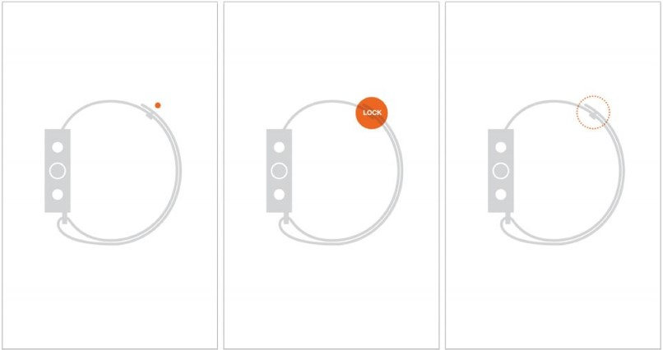
Figure 2 above illustrates the band and the band hook

3. Using the Dot Watch
[Downloading the Dot Watch App]
You can install our Dot Watch App on your smartphone by searching “Dot Watch” on iOS App Store or Google Play Store.

[Turning On]
Press and hold the “Home Button" for 3 seconds to turn on the device. The device will vibrate, and all the braille cells will come up for 3 seconds, and then go down.

[Turning Off]
Press and hold the “Home Button” for 3 seconds while powered on. The device will turn off after a vibration.

[Charging the Battery]
The battery should be fully charged before using the device for the first time. Charge the battery using the magnetic charging cradle (charger) supplied with the device for optimal charging. Personal computer or USB adapter can also be used to charge the battery.
1) Check the position of the metallic charging terminal on the back of the device and on the charger. This is outlined by a small indention on the back panel of the Dot Watch.
2) Face the charging terminal of the charger exactly to the charging terminal of the device, this protrudes from the flat cradle face slightly.
- The charger has a built-in magnet that assists with the positioning of the device when attempting to charge.
3) Connect the charger to an applicable USB terminal. Unless fully discharged, the device will vibrate when start charging.
4) When you connect the device with the charger, the device will vibrate and display “chrg” [dots 1,4/ dots 1,2,5/ dots 1,2,3,5/ dots 1,2,4,5] (⠉⠓⠗⠛) on the screen. Once the battery is fully charged, the device will vibrate twice and display to show the battery is full (⠿⠿⠿⠿).

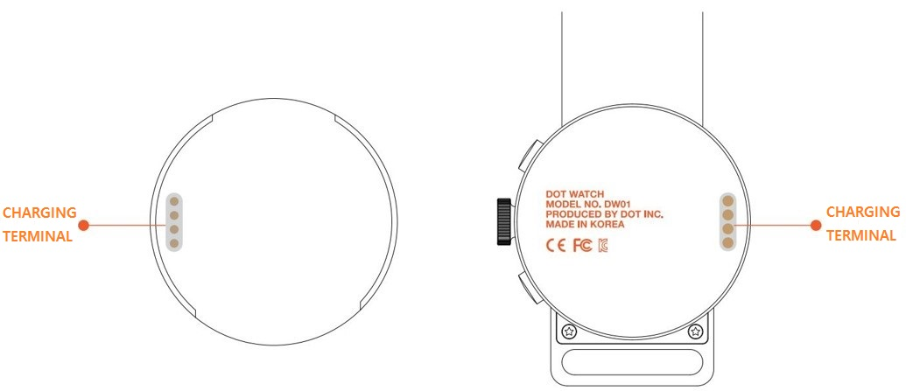
Figure 3. above illustrates the charging terminals

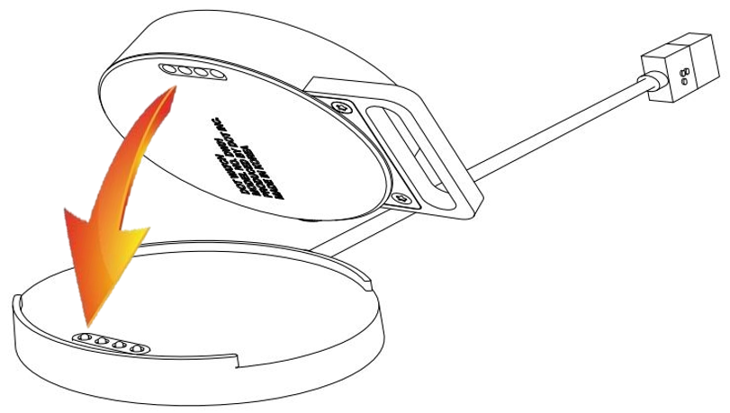
Figure 4. above illustrates connecting the charging terminal of the Dot Watch to the charging cradle

[Checking the Battery Status]
(While charging) Removing the device from the charger will display its remaining battery status.
(While on “Standby”) Turn the Dot Crown upwards once to display the remaining battery status.

[Pairing via Bluetooth]
1) Turn on the Bluetooth in your smartphone settings. Then, press and hold the “Home Button” of the Dot Watch to turn it on.
2) Run the Dot Watch App, choose “Start Pairing”, and search for the device under “Select your Dot Watch”. “Dot Watch DW-01,” and the last 4 digits of the product serial number will appear on the list, and selecting it will pair your Dot Watch to your smartphone.
3) Once connected, the device will vibrate and display in braille as described below:
Braille Mode: “conn” [dots 1,4/ dots 1,3,5/ dots 1,3,4,5/ dots 1,3,4,5] (⠉⠕⠝⠝) / Tactile Mode: (⠗⠒⠒⠺)
4) Even if the Bluetooth connection may be disconnected, the time and date will still be displayed on the device as synchronized with the smartphone.
*Repeat the procedures above if the connection fails. If the problem persists, please contact us through the official Dot Website or E-mail us at support@dotincorp.com for assistance.

[Unpairing the Bluetooth Connection]
From the Dot Watch App on your smartphone, go to “Dot Watch”. Choose “Unpair”, and select “Yes” to proceed to unpairing. “Unpairing” automatically deletes the Dot Watch information on your App, and resets your Dot Watch.
* Note that “Unpairing” is not advised unless attempting to connect the device to a new smartphone or replacing your Dot Watch.
* If your device unpairs from your smartphone due to any reasons (proximity, obstacles, powering off/on, etc.), refer to the steps in “Bluetooth Connection Status Menu” section to resume connection trials.

[Connecting the Dot Watch to a New Smartphone]
To pair the Dot Watch with a new smartphone, the Bluetooth information stored in both the previous smartphone and the Dot Watch needs to be reset. If you have paired your Dot Watch with a smartphone before, follow the steps below to reset and pair with a new one.
1) From the Dot Watch App – Dot Watch – choose “Unpair” to disconnect the Dot Watch from your smartphone. Here, both the Dot Watch and the Dot Watch information stored in your smartphone will reset.
2) To manually reset your Dot Watch, turn the “Dot Crown” upwards (clockwise) twice to navigate to the “Bluetooth Connection Status Menu”. Here, press and hold the “Home Button” for more than three seconds to reset your Dot Watch.
3) Once the Dot Watch is reset, it is ready to pair with another smartphone.

[User Guide]
You can refer to the Dot Watch User Guide from the Dot Watch App.
1) From the Dot Watch App, go to “Help”.
2) Choose “User Guide” to refer this manual organized by context.

[Sleep Mode]
If there is no operation or input for a user-specified “Standby Time”, all cells are automatically kept inside the display as the device enters “Sleep Mode”, which optimizes battery life.
While in “Sleep Mode”, Dot Crown operation is deactivated. To re-activate, press either buttons. The watch automatically re-activates when a buttons is pressed, receives alarms, notifications, or warnings.

[Setting the Standby Time]
1) From the Dot Watch App – Settings – Display Output, you can set your device’s “Standby Time”.
2) You can adjust the Standby Time from minimum 5 seconds to permanent.
3) Set the desired time by adjusting the bar, press ok to save and accept the change.

[Reverse Screen Mode]
Dot Watch offers the Reverse Screen Mode for your convenience.
Press the buttons in the following order to switch between the “Standard” and the “Reverse Screen Mode”:
Press the “Home Button” twice – “Select Button” twice – “Home Button” twice – “Select Button” twice –then press and hold the “Select Button”.
* Note that the left and right side of the “Touch Sensor” is reversed, however, the function or the direction of the “Select / Home Buttons” and the “Dot Crown” will remain the same.

4. Dot Watch App
[Register]
After installing the Dot Watch App through the App Store (iOS) or Play Store (Android), register your account to fully enjoy the complete Dot Watch experience. Please register with correct information for us to verify your order information, and to provide quality customer support.

[Log-in]
You can use the Dot Watch App after logging in with your account. Please note that it is a one-time log-in, and you can also log-in with either your Facebook or Google account.

[Resetting Your Password]
If you have forgotten your password, choose “Forgot password?” at the bottom of the screen. Enter your e-mail address and choose “Next” to continue. An instructional e-mail will be sent to your e-mail address. Please follow the steps to reset your password.

[Dot Watch App Functions]
1. Hi! User
Here, you can view or change your user account information.
You can change your username and password, or log-out.

2. Dot Watch
You can check your Dot Watch’s product serial number and its current battery status, or “Unpair” with your smartphone.
Note that “Unpairing” resets both the Dot Watch and its information stored on your smartphone.

3. Functions
You can use the “Alarm”, “Saved Message”, and “Study Braille” functions.
[Alarm] You can set up to 2 alarms at a time.
[Saved Messages] You can save and easily access the message here by pressing and holding the “Select Button” while reading the message on your Dot Watch.
[Study Braille] You can type any texts on your smartphone to display in Braille on your Dot Watch.
4. Settings
[About Dot] You can check your specific device details: i.e. “Dot Device Type”, “Firmware Version”, “Protocol Version”, and “Serial No.”.
[Watch Modes] You can choose and switch between the “Braille Mode” and the “Tactile Mode”. The “Tactile Mode” is our unique braille representation for people who are not familiar with the standard formats of braille.
[Notification] you can specifically set which notifications to be received and displayed on your Dot Watch. Make sure that your desired applications are checked to receive the notifications on your Dot Watch.
(iOS) You can choose to either turn on or off all notifications from messages, phone calls, and other applications.
(Android) You can choose to turn on or off each and every applications available (phone calls, messages, and mobile applications).
[Firmware Update] You can check the current firmware version, and update to its latest version, once available. The firmware update is not possible if the device is not paired with your smartphone via the Dot Watch App. Please check and maintain your mobile network connection when updating. After an update, reconnect the device with your smartphone.
[Languages] You can choose the language of the braille and its grades. The device supports up to two different languages at a time, and each language’s grade (if supported) can also be selected.
[Display Output] You can change the “Auto-scroll Speed”, “Vibration Intensity”, “Standby Time”, “Number of Pin Repetitions”, and “Number of Cell(s) Auto-scrolled”.
The “Number of Pin Repetitions” is a function that readjust the braille output that has not correctly displayed. If set to 0, the braille display receives one signal to raise or drop the pin. Likewise, setting it to 1 or 2 will receive additional one or two signals to raise or drop the pin.
* Increasing the “Number of Pin Repetitions” may consume more battery.
* It is recommended to reduce the “Number of Pin Repetitions” as Dot Cells’ movements become more familiar.
The “Number of Cell(s) Auto-scrolled” allows you to choose from either moving one or four cells at a time for your reading preference.

5. Help
Here, you can “Contact Us” to find out more about the Dot Watch, read the “User Guide”, or run the “Tutorial”.
In addition, you can read more about our Terms of Service, Privacy Policy, and Open Source Licenses.

5. Dot Watch Functions – Braille Mode, Tactile Mode
5-1) Common Functions
[Learning Braille]
From the Dot Watch App - Functions – Study Braille, you can type any message on your smartphone to display it in braille on the device. Try this method of learning the Braille with the Dot Watch.

[Receiving Phone Calls]
While the device is paired with your smartphone, you can be notified of incoming calls on its braille display. Upon receiving a call, the device will vibrate repeatedly and “call” [dots 1,4/ dot 1/ dots 1,2,3/ dots 1,2,3] (⠉⠁⠇⠇) appears.
Press the “Home Button” to reject the call immediately, or press the “Select Button” to check the caller information. If the contact is saved on the smartphone, you can check the caller's name in Braille. If the contact is not saved, you can check the number in Braille. Use the “Touch Sensor” to view the caller information.
While checking the caller information, press the “Home Button” to reject the call, or press the “Select Button” to answer. Please note that the Dot Watch does not have a microphone! You will need your smartphone to carry out the call after receiving it.
(iOS) While checking the caller information, press the "Select Button" to receive the call, or press the "Home Button" to reject the call. Receiving or declining a call will take the device back to its “Standby” status.
(Android) Depending on your smartphone, reception and rejection functions may be restricted.

[Finding My Smartphone]
While the device is paired with your smartphone, you can call up the smartphone by pressing both the “Select Button” and the “Home Button” twice at the same time in quick succession. The smartphone will vibrate with alarming sound. Use this function to easily locate your smartphone.

[Remaining Battery Indicator]
From “Standby” status, turn the Dot Crown upward once to check the remaining battery. The remaining battery is displayed with the numbers of pin raised on the screen. For example, if all 24 braille pins are raised, it means the battery is fully charged. If half of the total pins are raised, it means the battery is at 50%. The bottom row is always displayed to let you know the base of the remaining battery level.
E.g.) 100%: (⠿⠿⠿⠿), 50%: (⠿⠿⠤⠤)

[Battery Warnings]
Once the remaining battery level is down to 20% and 10%, the device will vibrate 3 times and displays its battery status. Battery charging is recommended at this time.

[Reading Notifications]
With the Dot Watch, you can check the content of text messages, application notifications, social media notifications, and etc., as well as its sender, and the time of receipt.
1) Upon receiving a notification, the device briefly vibrates twice.
2) Press the “Select Button” to begin reading the notification - in the order of the application name, sender information, contents, and timestamp.

[Methods of Reading the Notifications]
There are two ways of reading the notifications.
1) Touch-Assisted Scroll Mode
- Press the right “Touch Sensor” once to display the next 4 characters of the message. Press the left “Touch Sensor” to read the previous 4 characters. When at the end of the message, vibration will occur to notify that it is the end of the message. Here, press the “Select Button” to go back to the beginning of the message.
- Note that the “Touch Sensors” are programmed not to work while the pins are still in the movement; therefore, pressing the “Touch Sensors” repetitively while the pins are still moving may cause the sensors not to fully respond. In this case, give it about one second, and scroll again.

2) Auto Scroll Mode (Advanced Option)
- Auto Scroll is a way to read the notification without having to use the “Touch Sensor”. Press the “Select Button” while reading the notification to begin auto-scrolling. Press the “Select Button” once more to go back to the “Touch-Assisted Scroll Mode”.
  - Adjusting the number of moving cells and output speed
You can use the Auto Scroll in a variety of ways depending on your reading skill.
From the Dot Watch App – Settings – Display Output – Auto-scroll Speed, you can customize the speed of the auto scrolling. Also, you can choose between whether to refresh 1 character or 4 characters of the message at a time, under “the Number of Cell(s) Auto-scrolled”.
  - Going back to the beginning of the message
When at the end of the message, vibration will occur to notify that it is the end of the message. Here, press the “Select Button” to go back to the beginning of the message.

[Saving Notifications on the Dot Watch App]
While reading the notification, if you feel a need to save the message, press and hold the “Select Button” to save. You can check your saved messages through the Dot Watch App, under Functions – Saved Message.

[Checking Saved Notification Messages]
Up to 100 smartphone notification messages can be stored in the device. Notification messages are displayed in the following order: name of the app, sender information, notification content, and timestamp. If no notifications are found, “none” [dots 1,3,4,5/ dots 1,3,5/ dots 1,3,4/ dots 1,5] (⠝⠕⠝⠑) is displayed.
1) From the “Standby” status, turn the Dot Crown downward once to browse notification messages – “noti” [dots 1,3,4,5/ dots 1,3,5/ dots 2,3,4,5/ dots 2,4] (⠝⠕⠞⠊) will appear on the display.
2) Press the “Select Button” and turn the “Dot Crown” to check the notification numbers in the latest received order.
3) Press the “Select Button" to view the message.
4) While reading the notification, turn the “Dot Crown” up or downwards to access next or previous notification message.

[Alarm Function]
From the Dot Watch App - Functions - Alarm, you can set up to 2 alarms at a time.
The device will vibrate and the alarm number will be displayed as it goes off.
[Braille Mode] the alarm number is shown in braille.
[Tactile Mode] the first alarm is indicated as (⠯⠽⠀⠈) and the second alarm is indicated as (⠯⠽⠀⠠).

[Resetting the Dot Watch]
From the “Standby” status on your Dot Watch, turn the Dot Crown upwards twice to navigate to the Bluetooth Connection Status Menu. Press and hold the "Home Button" to reset all the Dot Watch settings.
5-2) Braille Mode
[Time]
The time of your smartphone is automatically synchronized to your Dot Watch when paired. The time function continues to operate even after the connection to the smartphone is lost. By default, the time is displayed in 24 hours.
While at “Standby” status, press the “Select Button" once to display the time. The left two cells indicate the hours and the right two cells indicate the minutes. Press the “Select Button" once more to check the seconds.
To switch the time displaying in 24 hours to 12 hours, press and hold the “Select Button” while viewing the time (hours and minutes). Press the “Select Button” to check the current second and AM or PM. Here, the left two cells indicates the seconds, and the right two cells tell “am” [dot 1, dots 1,3,4] (⠁⠍) or “pm” [dots 1,2,3,4, dots 1,3,4] (⠏⠍).

[Date]
The date of your smartphone is automatically synchronized to your Dot Watch when paired. The date function continues to operate even after the connection to the smartphone is lost.
While at “Standby” status, press the “Select Button" three times to display the current date. The left two cells reads the months, the right two cells reads the date. Pressing and holding the “Select Button” while viewing he date will switch the order of the months and date – from MMDD to DDMM.

[Setting the Time Manually]
You can also use all the basic watch functions while the Dot Watch is unpaired.
1) Press and hold both the “Select Button” and the “Home Button” at the same time to set the time manually – “set” [dots 2,3,4/ dots 1,5/ dots 2,3,4,5] (⠎⠑⠞) will appear on the screen.
2) Press the “Select Button” to set the first cell (the first digit of hours in 24, which is 0~2). Turn Dot Crown to adjust. Once set, press the “Select Button” to move on to the second cell (the second digit of hours in 24, which is 0~9). Respectively, set the third cell (the first digit of minutes in 59, which is 0~5), and the fourth cell (the second digit of minutes in 59, which is 0~9).
3) After setting the hours and minutes, press the “Select Button" and repeat the above procedures to set the seconds on the third and fourth cells: third cell (the first digit of seconds in 59, which is 0~5), and the fourth cell (the second digit of seconds in 59, which is 0~9).
4) Upon setting the seconds, press the “Select Button”, it will vibrate to signal completion of the time setting.

[Setting the Date Manually]
1) Press and hold both the “Select Button” and the “Home Button” at the same time to set the time manually – “set” [dots 2,3,4/ dots 1,5/ dots 2,3,4,5] (⠎⠑⠞) will appear on the screen.
2) Press and hold the “Select Button” to move onto the date setting. The year of the default date will appear as “2017” [dots 1,2/ dots 2,4,5/ dot 1/ dots 1,2,4,5] (⠃⠚⠁⠛)
3) Turn the Dot Crown up (+1 year) or down (-1 year) to set the year, then press the “Select Button" to move on to set the month and date.
4) Set the first cell (the first digit of months in 12, which is 0~1). Turn Dot Crown to adjust. Once set, press the “Select Button” to move on to the second cell (the second digit of months in 12, which is 0~9). Respectively, set the third cell (the first digit of date in 31, which is 0~3), and the fourth cell (the second digit of date in 31, which is 0~9).
5) Upon setting the last cell, press the “Select Button”. The device vibrates, and date setting (month and date) is completed.

[Stopwatch] (from 1 second to maximum 23hours 59 minutes)
Follow the guideline below to use the Stopwatch function. The stopwatch will still run in the background when left un-paused. The four cells will display minutes and seconds up to 59 minutes and 59 seconds. From 1 hour and on, the four cells will display only the hours and minutes.
1) From the “Standby” status, turn the Dot Crown downward twice to access the stopwatch function – “stop” [dots 2,3,4/ dots 2,3,4,5/ dots 1,3,5/ dots 1,2,3,4] (⠎⠞⠕⠏) will appear on the screen.
2) Press the “Select Button” to enter the stopwatch – “0000” [dots 2,4,5/ dots 2,4,5/ dots 2,4,5/ dots 2,4,5] (⠚⠚⠚⠚) will appear on the screen.
3) Press the “Select Button” to start/pause/resume the stopwatch.
4) Press and hold the “Select Button” to reset – “0000” [dots 2,4,5/ dots 2,4,5/ dots 2,4,5/ dots 2,4,5] (⠚⠚⠚⠚) will appear on the screen.

[Timer]
Follow the guideline below to use the Timer function (the count limit is 59 minutes and 59 seconds). The timer will still run in the background when left un-paused.
1) From the “Standby” status, turn the Dot Crown downward 3 times to browse the timer function – “timr” [dots 2,3,4,5/ dots 2,4/ dots 1,3,4/ dots 1,2,3,5] (⠞⠊⠍⠗) will appear on the screen.
2) Press the “Select Button” to enter the timer. Here, the left two cells are indicate the minutes, and the right two cells indicate the seconds. Turn the Dot Crown to set the digit, and press the “Select Button” to move onto the next cell. After settings the seconds, press the “Select Button” to start the countdown.
4) While counting down, press the “Select Button” to pause. Press it again to resume.
5) When the countdown is completed, “tout” [dots 2,3,4,5/ dots 1,3,5/ dots 1,3,6/ dots 2,3,4,5] (⠞⠕⠥⠞) will appear with vibrations to notify. Press the “Home Button” to dismiss the timer notification, or it will be dismissed automatically after 5 minutes.

[Bluetooth Connection Status Menu]
Follow the guideline below to check the Bluetooth pairing status or resume Bluetooth connection trials.
1) Turn the Dot Crown upwards twice to display the Bluetooth Connection Status Menu.
If connected, “conn” is displayed [dots 1,4/ dots 1,3,5/ dots 1,3,4,5/ dots 1,3,4,5] (⠉⠕⠝⠝)
If disconnected, “disc” is displayed [dots 1,4,5/ dots 2,4/ dots 2,3,4/ dots 1,4] (⠙⠊⠎⠉)
2) If there hasn’t been any Bluetooth connection activities for 30 minutes, the Dot Watch stops the Bluetooth signaling to optimize the battery life.
3) If your device unpairs from your smartphone due to any reasons (proximity, obstacles, powering off/on, etc.), follow the steps below to resume connection trials.
- Run the Dot Watch App on your smart phone
- Press the “Select Button” while on the Bluetooth Connection Status Menu to resume connection trials.

5-3) Tactile Mode
[Switching to Tactile Mode]
Anyone not familiar with Braille can still use all the basic watch functions with Tactile Mode.
(Switching via the Dot Watch App) From the Dot Watch App – Settings – Watch Modes, you can change between the Braille Mode and the Tactile Mode.
(Switching without using the App) Press the “Home Button” - “Select Button” - “Home Button” - press and hold “Select Button” to shift into Tactile Mode. The device will vibrate and notify that the mode is changed. You can switch back to its default, Braille Mode by repeating the above command.
While in Tactile Mode, the pins are always raised to display the time (unless the “Home Button” is pressed to go to “Standby”).

[Time]
The time of your smartphone is automatically synchronized to your Dot Watch when paired. The time function continues to operate even after the connection to the smartphone is lost.
1) Press the “Select Button” to check the time. The left two cells indicate the hours, and the right two cells indicate the minutes.
2) The number of pins on the left two cells indicate the hour. 3 pins tell 3 o'clock E.g.) 03:42 (⠋⠀⠿⠉)
3) Each pin on the right two cells indicates 5-minute intervals of the hour. 8 pins tell minutes between 40~44 minutes. E.g.) 03:42 (⠋⠀⠿⠉)
4) Press the “Select Button” one more time to check the exact minutes. The left two cells here display the minutes in tens, while the right two cells display minutes in ones. E.g.) 42 minutes: (⠛⠀⠉⠀)

[Setting the Time Manually]
1) Press and hold both the “Select Button” and the “Home Button” at the same time to set the time manually – “set” [dots 2,3,4/ dots 1,5/ dots 2,3,4,5] (⠎⠑⠞) will appear on the screen. Press the “Select Button” to set the left two cells (hours).
2) Turn the Dot Crown to set the hours between 0~12, press the “Select Button” to move on to set the minutes.
3) Set the first cell (minutes in tens, between 0~5), press the “Select Button” to set the third and fourth cells (minutes in ones, 0~9).
4) Press the “Select Button” to complete. A vibration will notify that the time is set.

[Stopwatch] (from 1 second to maximum 6 minutes and 59 seconds)
Follow the guideline below to use the Stopwatch function while in Tactile Mode. The stopwatch will still run in the background when left un-paused. The first cell on the left indicate minutes, the second cell indicates seconds in tens. The right two cells indicate seconds in ones.
1) From the “Standby” status, turn the Dot Crown downward twice to access the stopwatch function – “stop” [dots 2,3,4/ dots 2,3,4,5/ dots1,3,5/ dots 1,2,3,4] (⠎⠞⠕⠏) will appear on the screen.
2) Press the “Select Button” to enter the stopwatch function, you will notice all the pins are put down.
3) Press the “Select Button” to start the stopwatch.
4) While the stopwatch is operating, press the “Select Button” to pause. Press the “Select Button” again to resume.
5) Press and hold the “Select Button” to reset. Press the “Select Button” to start a new cycle.

[Timer]
Follow the guideline below to use the Timer function while in Tactile Mode (the count limit is 5 minutes and 59 seconds). The timer will still run in the background when left un-paused. The first cell on the left indicate minutes, the second cell indicates seconds in tens. The right two cells indicate seconds in ones.
1) From the “Standby” status, turn Dot Crown downward 3 times to browse timer function – “timr” [dots 2,3,4,5/ dots 2,4/ dots 1,3,4/ dots 1,2,3,5] (⠞⠊⠍⠗) will appear on the screen.
2) Press the “Select Button” to enter the timer, you will notice all the pins are put down. Turn the Dot Crown to set the first cell – minute in ones (0~6). Press the “Select Button” to move to the second cell – seconds in tens (0~5). Press the “Select Button” to move to the third and fourth cells – seconds in ones (0~9). Once adjusted to your desired time, press the “Select Button” to start the countdown.
3) While the counting down, press the “Select Button” to pause. Press the “Select Button” again to resume.
4) When the countdown is completed, “tout” [dots 2,3,4,5/ dots 1,3,5/ dots 1,3,6/ dots 2,3,4,5] (⠞⠕⠥⠞) will appear with vibrations to notify.

[Bluetooth Connection Status Menu]
Follow the guideline below to check the Bluetooth pairing status or resume Bluetooth connection trials.
1) Turn the Dot Crown upwards twice to display the Bluetooth Connection Status Menu.
If connected, (⠗⠒⠒⠺) is displayed.
If disconnected, (⠇⠀⠀⠸) is displayed.
2) If there hasn’t been any Bluetooth connection activities for 30 minutes, the Dot Watch stops the Bluetooth signaling to optimize the battery life.
3) If your device unpairs from your smartphone due to any reasons (proximity, obstacles, powering off/on, etc.), follow the steps below to resume connection trials.
- Run the Dot Watch App on your smart phone
- Press the “Select Button” while on the Bluetooth Connection Status Menu to resume connection trials.

6. Precautions
6-1) Safety Precautions
[Lightning Hazards]
When thunder or lightning is severe, it is advised not use the device. Disconnect the charger from its power source.
A Lightning strike may cause serious injury or fire.

[Use in Restricted Areas]
Do not use the device in restricted areas where the use of electronic device is prohibited, such as in the airplanes, hospitals, etc.
Note that some electronic / communication devices may be affected by electromagnetic waves when using the device.
The device may pass safely through an airport X-ray scanner; however, it is advised not to wear the device while passing through a metal-detecting security terminal.

[Disassemble Precautions]
Do not disassemble or shock the device. There may be risks of electric shock, short circuiting, or fire.
Do not use damaged devices. There may be risks of fire, burn, injury or electric shock.
If the device is damaged or malfunctions, contact the nearest customer service center.
Disassembling the device at-will may damage the device. In the case that you may need to disassemble the device, please visit the nearest service center. Unauthorized disassembly will avoid your warranty and may cause irreparable damage to the device and/or cause bodily harm.

[Power Precautions]
Insert the charger USB cable correctly and make sure it is firmly connected.
Do not bend, pull, twist, heat, or cut the charging cable. Doing so may damage the cable and cause fire or electric shock.
Do not place any heavy materials on the charger.
When cleaning, it is advised to disconnect the cable, as there may be risks of fire or electric shock.
Avoid vibration or shock and disconnect the charger when not in use.
Do not use the charger if the USB connector is loose or damaged. If the connection is unstable, it may cause damage and/or ignite.

[High Temperature and Humidity Precautions]
Do not use the device in hot or humid places.
Do not place the device in direct sunlight or under a heater, quilt, carpet for extended periods of time, or in a hot or humid environment such as steam room or sauna.
Normal operating temperature: 0~40 ºC

[Chemical Precautions]
Do not use alcohol, benzene, acetone, or any other chemical-based solutions to clean the device. The device may malfunction or may cause fire or irreparable damage to the device.
To clean, gently wipe the device with a soft cloth.
If you require assistance with cleaning the device, please contact our customer support.

[Metal Precautions]
Do not place charging terminals close to exposed metal, such as necklaces, keys, coins, nails, watches, etc.
If metal objects are shorted to the charging terminal, there may be risk of explosion and/or irreparable damage to the device.

[Children/Pets Precaution]
Store the device, charger, and parts away from children and pets.
The device may cause electric shock, or cause exposure to electromagnetic waves when damaged or in contact with saliva.
Be careful to keep children and pets away from the device. Swallowing or biting the device, charger, or parts may cause suffocation, and or bodily harm.
Keep the device, charger, or parts away from sharp metal objects, such as keys, hairpins, coins, or nails. Any unintended pressure to the battery may compromise the quality and/or cause irreparable damage to the charger.

[Hazardous Area Precaution]
Do not use the device in magnetic-sensitive atmosphere. It may affect high-frequency equipment.
Do not place the device in an unstable place, such as a vibrating surface or a sloping area. Failure to do so may damage the device and/or cause bodily harm.

[Fire Precaution]
Do not wrap the device or cover with insulation when in-use or when charging.
Make sure to recycle it correctly. Disposing electronic device in the trash may cause environmental damage.
If you need assistance with disposing the device, battery and/or the charger, please contact your local authorities.
[Skin Damage Precaution]
When using the device for a long time, the temperature of the surface of the device may rise. This is a normal instance and should not affect the standard operations of the device. Cease using the device immediately if it causes skin spots, pigmentation, or burns.
If the device causes any allergic reaction, stop using the device immediately and consult a doctor.
Cease using the device if the top cover is damaged to expose any of the inner mechanical parts of the device.

[Magnetism Precaution]
Do not be in close contact with objects with underlying magnetic chips, such as credit cards, phone cards, bankbooks, and tickets. Information may be damaged due to the device’s magnetic property.
Do not use the magnetic charging cradle with any other objects, as it contains stronger magnet that may interfere with pacemakers, credit cards, watches, and other magnetically-sensitive objects.

[Storage Precaution]
When not in use, disconnect the charging cable from the outlet and store it in a safe place.

[Battery Precaution]
In hot or humid places, the battery may not charge well or may be consumed more quickly than average.
If you want to use the device again after ceasing for a prolonged period, use it after the device is fully charged.
Removing the battery by force may cause it to ignite or explode.
Do not expose the battery or charger to direct sunlight or use it in a place with high humidity, such as a sauna or a heated automobile.
Do not open, disassemble, damage, bend, deform, puncture, or crush the device.
Do not attempt to alter or modify the battery, insert foreign objects, immerse or expose to water or other liquids.
Once the device is fully charged, disconnect the charger from the outlet to prevent unnecessary power consumption.
It is recommended to bring both the device and charger when visiting our service center due to any customer issues.
There may be risks of fire or explosion, if the batteries are not replaced correctly.
Dispose of used batteries according to Dot Incorporation’s authorized instructions.

6-2) Handling Precautions
The contents of this User's Guide are based on the default settings of the device.
The contents of this manual may differ from the actual device experience depending on the software version, firmware version, telecommunication service, model specifications, and the user's customized settings.
If water or dust gets into the device, it may damage or cause the device to malfunction. To maintain normal functionality, carefully follow the precautions below:
When the cells are compromised by liquids, turn off the power and let it dry completely before use. The device may be damaged if the user attempts to operate the device while the cells are not completely dry.
Be warned that the device may be damaged if dropped or under heavy pressure.
When using in a dusty environment, dust may accumulate inside the cells and interfere with proper operation and/or irreparably damage the device. Please exercise caution.
The Warranty service does not apply to problems caused by installing and/or operating the device alongside unauthorized third party software and hardware.
If the user modifies the device's registry settings or firmware to arbitrarily change the function or compatibility, the device may not work properly and the warranty will be void.
The applications and services provided in this device may be changed or discontinued by Dot Incorporation without notice when inevitable circumstances present themselves.
If the user changes any of the software provided by Dot or download software for the device that is obtained through other means than the official channels for distribution, the device may malfunction or damage irreparably. In this case, warranty service will be void.
The Dot Watch currently does not provide services related with personal safety and health due to possible radio wave interference with life-support mechanisms.
Due to development circumstances, basic components may change without a prior notice.
Device design and specifications may change without notice for performance improvements.
Please use approved accessories provided and authorized by Dot Incorporation. Use of non-genuine parts and components may result in device malfunction and/or irreparable damage. In this case, warranty service will be void.

7. Dot Watch Specifications
[PLATFORM]
Platform: Wireless MCU Platform
Bluetooth: Bluetooth LE (Low Energy) 4.2
CPU: 32-bit ARM Cortex M4F, M0 (Dual)
[DISPLAY]
Type: Refreshable Braille Display
Resolution: 4 Braille Cells (24 Dots)
[FEATURES]
Buttons/Switch: 2 Buttons, 1 Encoder Switch
Motor: Shaft Horizontal Vibration Motor
Sensors: Front Touch Sensors, Gyroscope (3 Axis)
[POWER]
Battery: Non-removable Li-Polymer 400mAh Battery
Charger: Cradle Dock
[DIMENSIONS]
Body: 43.0 D x 12.5 T (mm)
Band: 22.0 x 220(Small) / 250(Medium) / 290(Large) (mm)
Charger: 45.0 D x 7.0 T (mm)
[WEIGHT]
Body: 27g
Band: 8g
Charger: 20g
[MATERIAL]
Body: Aluminum Steel
Band: Natural Leather
Charger: Plastic
[COLOR]
Front: Off-White
Body: Silver
Band: Gray, Black
Charger: Gray

8. REGULATORY NOTICES

MODEL NUMBER: DW01
FCC STATEMENT

This device complies with part 15 of the FCC Rules. Operation is subject to the following two conditions: (1) This device may not cause harmful interference, and (2) this device must accept any interference received, including interference that may cause undesired operation.

FCC WARNING

Changes or modifications not approved by Dot Incorporation could void the user’s authority to operate the equipment.
Note: This equipment has been tested and found to comply with the limits for a Class B digital device, pursuant to part 15 of the FCC Rules. These limits are designed to provide reasonable protection against harmful interference in a residential installation This equipment generates, uses and can radiate radio frequency energy and, if not installed and used in accordance with the instructions, may cause harmful interference to radio communications, However, there is no guarantee that interference will not occur in a particular installation. If this equipment does cause harmful interference to radio or television reception, which can be determined by turning the equipment off and on, the user is encouraged to try to correct the interference by one or more of the following measures: - Reorient or relocate the receiving antenna. - Increase the separation between the equipment and receiver. - Connect the equipment into an outlet on a circuit different from that to which the receiver is connected. - Consult the dealer or an experienced radio/TV technician for help.

This device meets the FCC requirements for RF exposure in public or uncontrolled environments.

FCC ID: 2AKDG-DW01

Without permission, any company, firm or user shall not alter the frequency, increase the power, or change the characteristics and functions of the original design of the certified lower power frequency electric machinery.
The application of low power frequency electric machineries shall not affect the navigation safety nor interfere a legal communication, if an interference is found, the service will be suspended until improvement is made and the interference no longer exists. The foregoing legal communication refers to the wireless telecommunication operated according to the telecommunications laws and regulations. The low power frequency electric machinery should be able to tolerate the interference of the electric wave radiation electric machineries and equipment for legal communications or industrial and scientific applications.

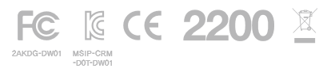

CE NOTICE
Declaration of Conformity with Regard to the R&TTE DIRECTIVE 1999/5/EC, LOW VOLTAGE DIRECTICE 2014/35/EU
Dot Incorporation is authorized to apply the CE Mark on the Dot Watch, Model DW01, thereby declaring conformity to the essential requirements and other relevant provisions of Directive 1999/5/EC.
Compliant with the standard R&TTE 1999/5/EC, Article 3(1)(a) – Health and Safety, Article 3(1)(b) – EMC, Article 3(2) – Radio
Compliant with:
EN 6095001:2006+A11:2009+A1:2010+A12:2011+A2:2013

EN 62311:2008

EN 301 489-1 V1.9.2

EN 301 489017 V2.2.1

EN 300 328 V1.9.1

It is confirmed that a sample of the product has been tested and found in conformity with below standard(s):
ROHS: EN 50581: 2012, IEC 62321-3-1: 2013

CHINA NOTICE
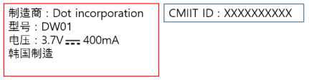

BLUETOOTH SIG NOTICE
The Dot Watch (DW-01) is acknowledged as being in accordance with the Bluetooth Qualification Process as specified within the Bluetooth Specifications and as required within the current PRD.

DISPOSAL AND RECYCLING INFORMATION

The symbol on the product or its packaging signifies that this product has to be disposed separately from ordinary household wastes at its end of life. Please kindly be aware that it is your responsibility to dispose electronic equipment at recycling centers so as to help conserve natural resources. Each country in the European Union should have its collection centers for electrical and electronic equipment recycling. For information about your recycling drop off point, please contact your local related electrical and electronic equipment waste management authority or the retailer where you bought the product.

- Do not dispose of your Dot Watch with household waste
- Disposal of the packaging and your Dot Watch should be done in accordance with local regulations.
- Batteries are not to be disposed of in municipal waste stream and require separate collection.
Please recycle! For additional information on disposal and recycling, including contact details of a distributor in your region, please contact dot@dotincorp.com

